Lab 5
Coding ARP with python Scapy
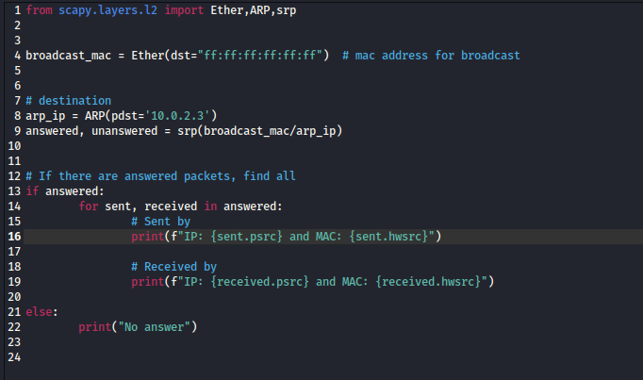

Execute the python script
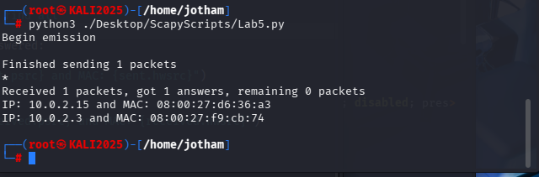

NETCAT
Listening for inbound connections on a port
nc -l -p port

Initiating connections to another machine’s port
nc <options> <IPAddress> <Port>

Banner Grab
Webserver interaction on Port 80
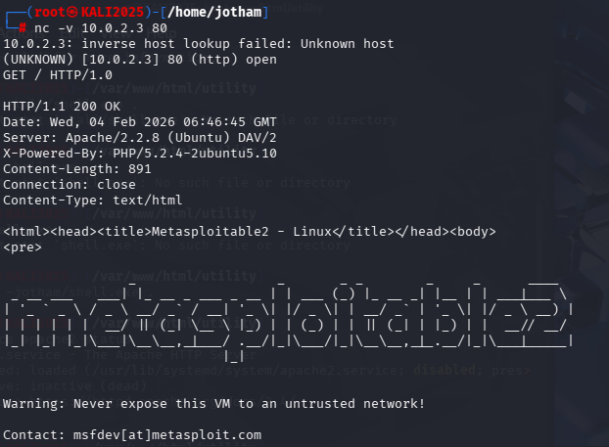
- HTTP interaction:
- GET /filepath HTTP/1.0 // HTTP GET
- Double <enter> to signal end of HTTP request
  - Blank line required after request headers
- Shows Apache server version and Device information:
  - Apache / (2.2.8) (Ubuntu) DAV/2
  - X-Powered by: PHP/5.2.4-2ubuntu2.10

Banner Grab and Raw connection on Port 21 and 22
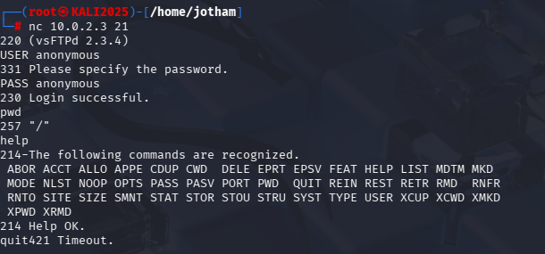
- Shows FTP server version (vdFTP 2.3.4)

- Interaction with FTP application:
- Log in as ‘anonymous’ user + Use ‘anonymous’ as password
- PWD Server shows root directory
- Help Shows all commands recognized
- Quit Terminate session

SSH protocol mismatch
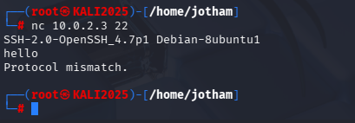
- Requires proper handshake
- Shows the version

Reverse shell
Text
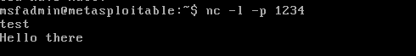
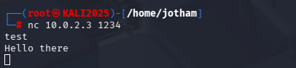
- Meta2 starts listening on port 1234
- Kali sends TCP messages to Meta2 (10.0.2.3) on port 1234

File transfer
Create file and send to Meta2 using Netcat
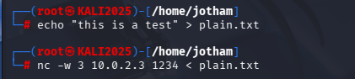
- Create a file and send using Netcat (include 3s timeout)

Set Netcat to listen on the port
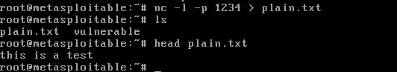
- Set Meta2 to listen on port 1234 before starting file transfer
- File is successfully received by Meta2

Creating a backdoor with /bin/bash (Bind) shell
Set Meta2 to listen mode for connection
- Meta2 executes ‘/bin/bash’ on another device as soon as connection is achieved

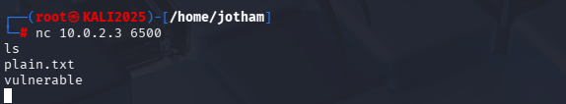
- Kali connects and has immediate access to the shell

Bind Shell Attacker initiates connection while victim is listening
- More likely to be dropped or detected (Firewalls are looking for incoming traffic)

Reverse Shell Attacker listens and Victim initiates the connection
- More successful since outgoing traffic allowed

Manual exploit of VSFTP
Use nmap to do version scan of Meta2
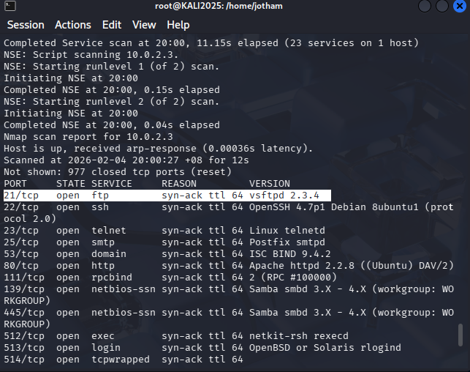

Check for version specific vulnerabilities on CVE database
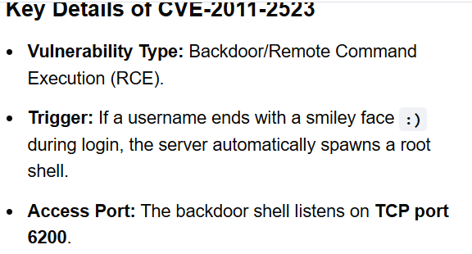
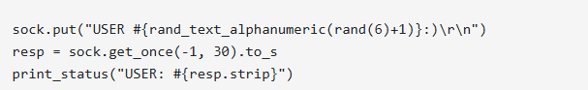

Use Netcat to exploit the VSFTP
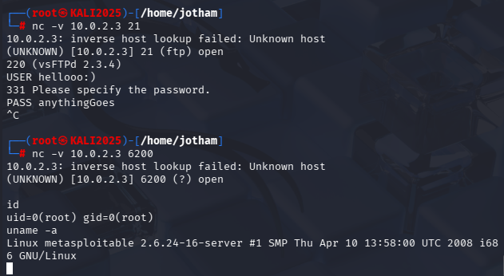
- Use Netcat to send a request to port 21 (VSFTPD)
- Enter the ‘USER’ field with ‘:)’ at the end

- Exit session and connect to port 6200

Use exploit:
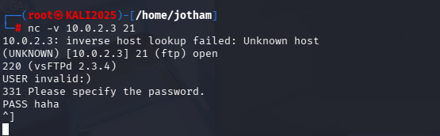

Exploited:
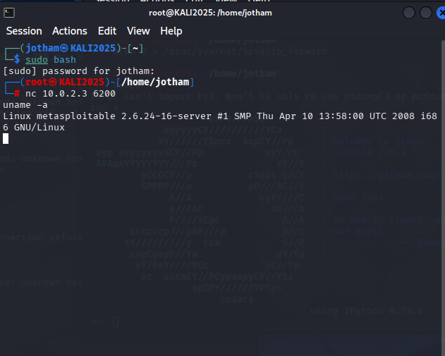

METASPLOIT on VSFTP
Use Nmap to scan the target
nmap -T5 -A 10.0.2.3
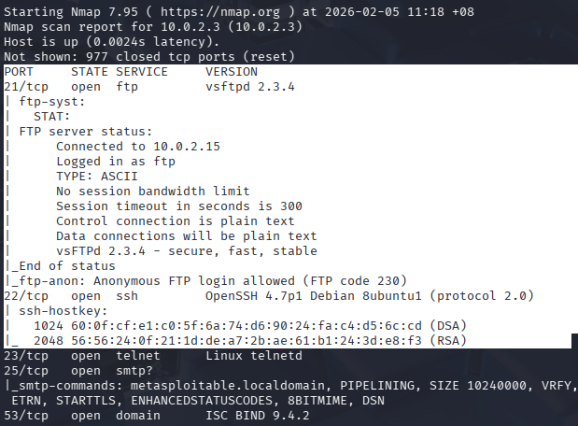
- Port 21 is open with VSFTP 2.3.4

Search Metasploit for exploits on VSFTP 2.3.4
search vsftp 2.3.4
use 0
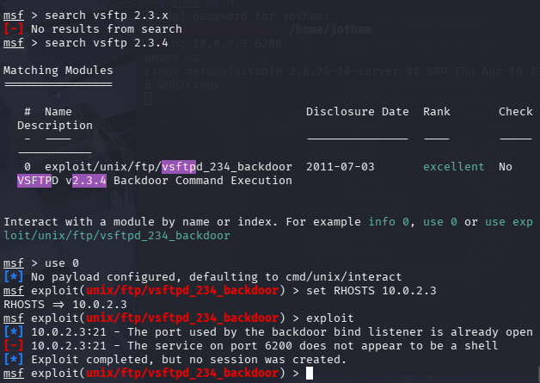
- Exploit module found and selected
- RHOSTS /receiving host set to target
(Required under ‘show options’)

Use the exploit to open a shell
set RHOSTS 10.0.2.3
exploit
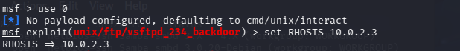
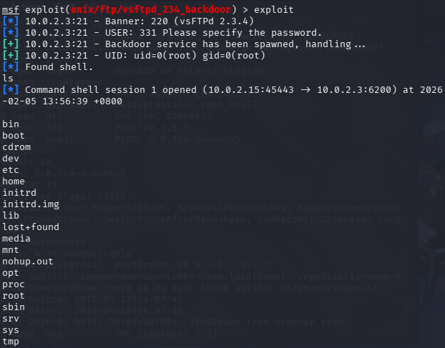
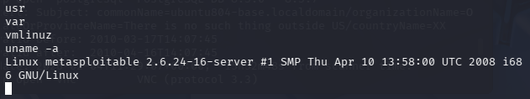
- Shell with root access to files created

Metasploit of Samba
Use NMAP to find the version
nmap -A -T5 10.0.2.3
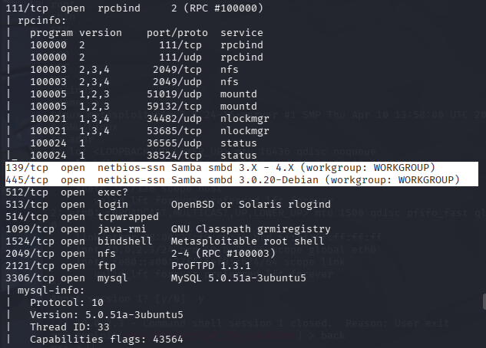

Search for the exploit on msfconsole
search Samba 3.0.20
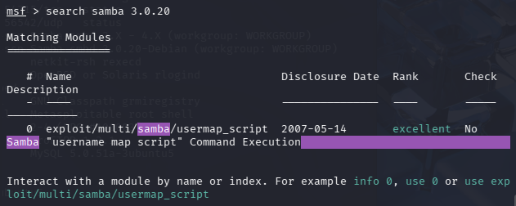

Use exploit and create reverse shell
set RHOSTS 10.0.2.3
exploit
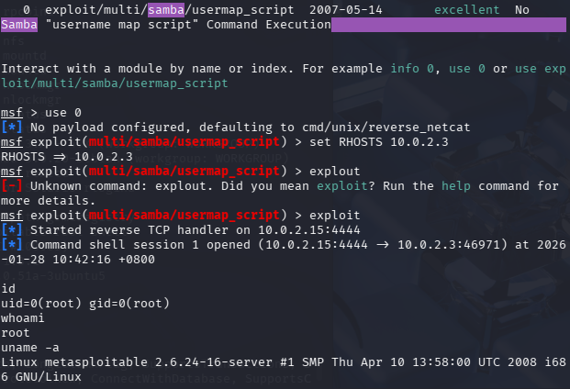

Metasploit of SSH and RPC
- Override network driver mount point such that you can login without password

Gather information on RPCBIND, NFS, SSH
Scan Ports 22 (SSH), 111 (RPCBIND), 2049 (NFS)
nmap -vvvv -sV 10.0.2.3 -p 22,111,2049
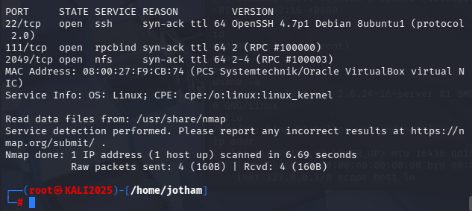

Understand how services are configured
rpcinfo -p 10.0.2.3
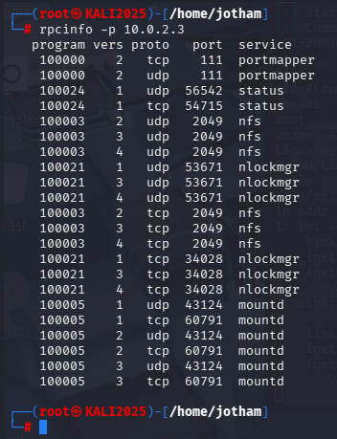
- RPC bind
- Acts as the directory of service names and port numbers
- All RPC services query the OS on start up for a port number and informs RPC bind

Adding SSH-RSA to Kali
- Enable an older deprecated security standard (SHA-1 hashing algorithm) in the ssh_config file

Find ssh_config file
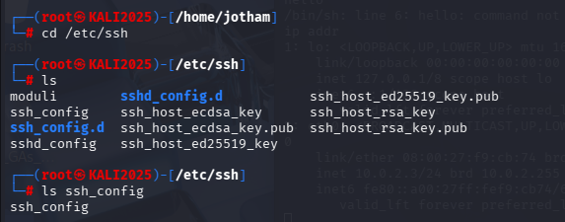

See ssh_config file contents live
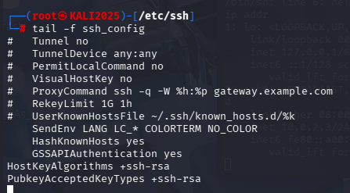
-f Follow live
tail shows last 10 line of the file

Append to config file using nano
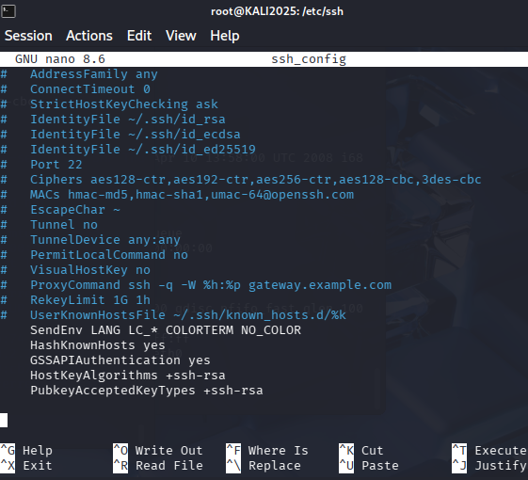

Restart SSH on Kali
- Restart SSH to allow the changes to take effect

systemctl restart ssh
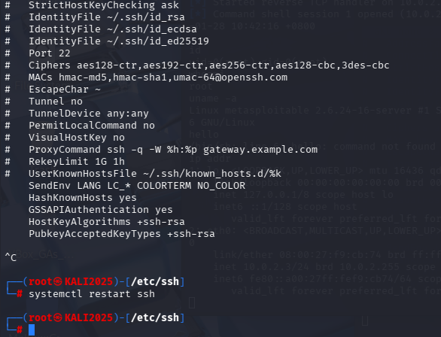
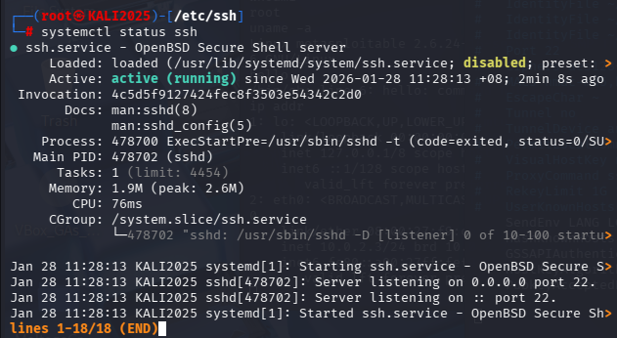

Check if Meta2’s mount can support file sharing
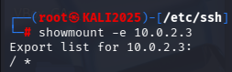
Mounting File system from another device placed in a directory of a local host machine

- ‘/ *’ shows all files and directories (root) can easily be accessed from any machine on the network

Generate Public key with Null private key
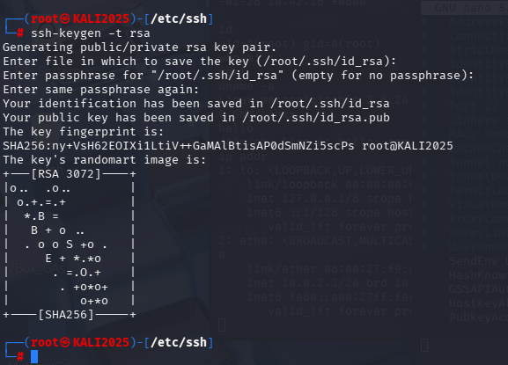
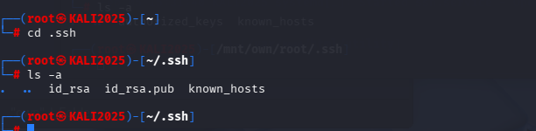
- Key is created:
PrivateKey ‘id_rsa’ file
PublicKey ‘id_rsa.pub’ file

- Copy public key to other server’s ‘.ssh/authorized_keys’ to login

Create mount point on Kali and Remote NFS to Meta2
Create ‘/mnt/own’ directory
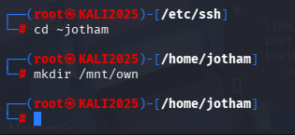

Mount meta2 root directory using NFS to the ‘/mnt/own’ directory
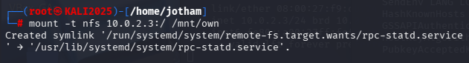

Copy RSA public key to meta2 root directory
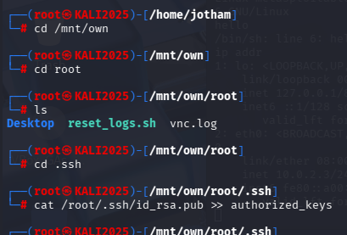
- Print the contents of the ‘id_rsa.pub’ (generated public key) into the ‘authorized_keys’ file in Meta2

Open new terminal and get reverse shell
ssh root@10.0.2.3
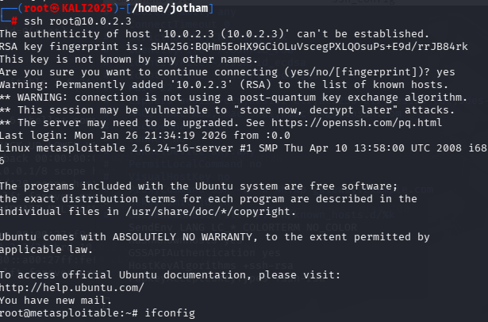
- Boots secure shell connection to Meta2 and log in as the root user

